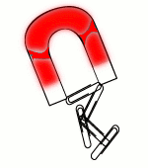
Name__________________ Date________ Due Date_________
Discussion Questions for Fish and Clips
Directions: Please answer each question to the best of your ability. Use complete sentences unless otherwise directed.
When you went “fishing” why did some clips drop off?

Did this happen more with one size clip than the other? (Circle One) Yes No

Which group had the largest average catch? (Circle One) Small Clips Large Clips
How did you figure out the average?

Why did we do five trials and average them, instead of having just one trial?

