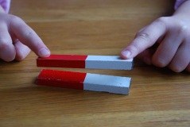
Name__________________ Date________ Due Date_________
Discussion Questions for How Close Can You Get?
Directions: Please answer each question to the best of your ability. Use complete sentences unless otherwise directed.
What is happening as you move the magnet toward the paper clip, before the clip moves?

Why are we experimenting three times and then averaging the results?

Did you get nearly the same result each time? Yes No
If not, why do you think it was different? What factors were different?

What patterns did you see as you added the second and third magnet units?

What would happen if you added a fourth or fifth magnet unit?

